**To Explore Business Analytics Task-5**

**DASHBOARD**

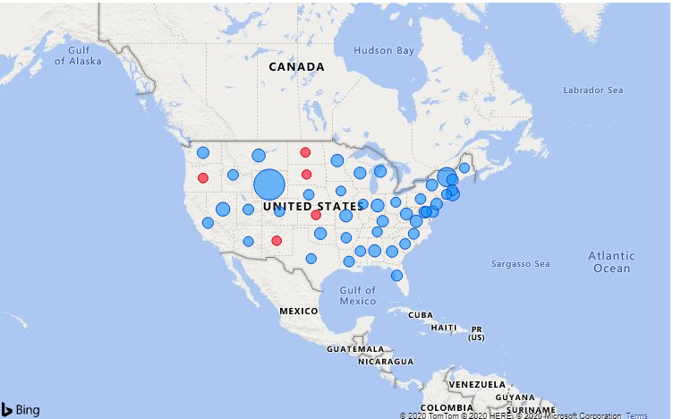

Average of Sales by State

THE LARGER BLUE BUBBLE DENOTES THE PLACE WHERE MAXIMUM SALE OCCURRED. THE RED BUBBLES IN THE VISUAL DENOTE THE PLACE WHERE THE SALE IS LESS.

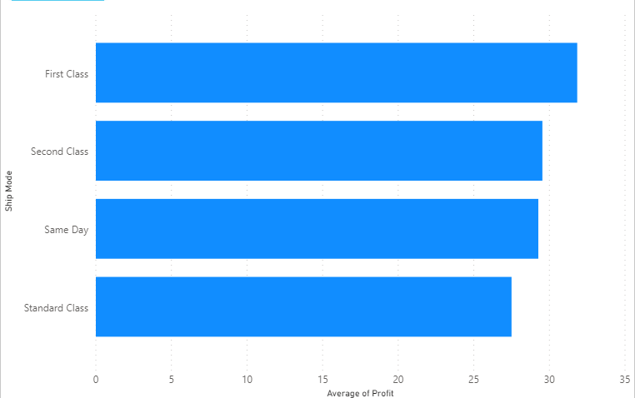

Average of Profit by Ship Mode

THE COMPANY GET MAXIMUM PROFIT BY SHIPPING THE GOODS IN FIRST CLASS

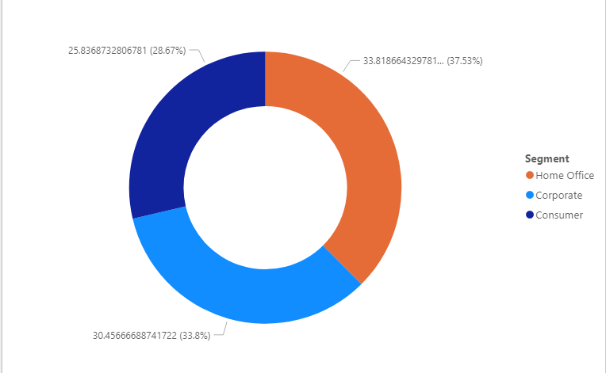

Average of Profit by Category

THE MAXIMUM GOODS SOLD FOR HOME OFFICE SEGMENT

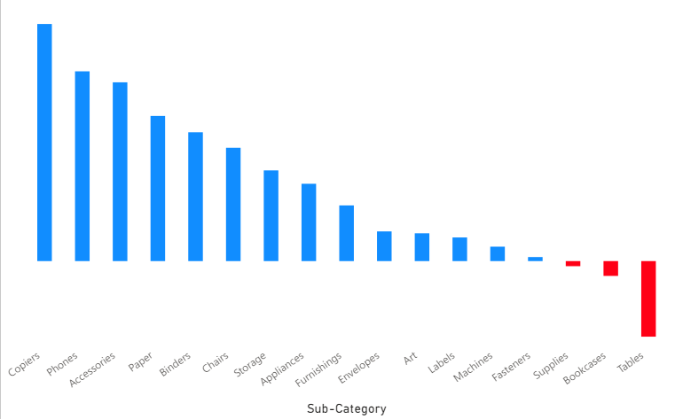

Average of Profit by Category

THE COMPANY GET LOSS WHEN THEY SOLD BOOKCASES, SUPPLIES AND TABLES.

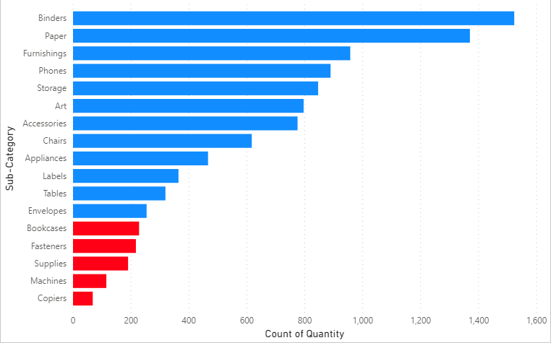

Count of Quantity by Sub-Category

COMPANY SOLD BOOKCASES, FASTENERS, SUPPLIES, MACHINES, COPIERS IN LESS COUNT

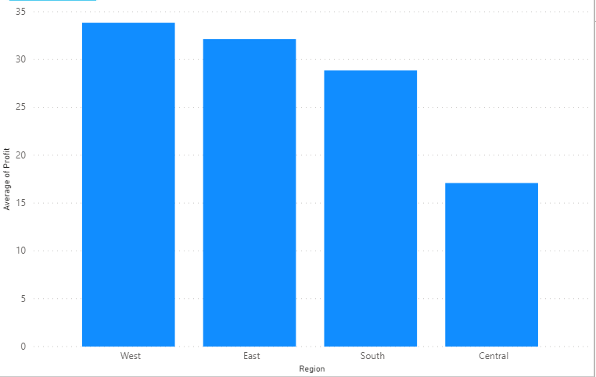

Average of Profit by Region

THE AVERAGE OF PROFIT IS MAXIMUM IN WEST ZONE AND MINIMUM IN CENTRAL ZONE

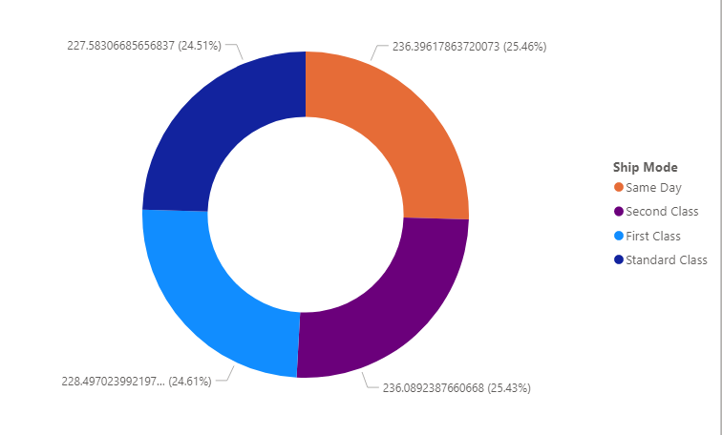

Average of Sales by Ship Mode

SHIP MODE IS NEARLY EQUAL FOR All CLASS

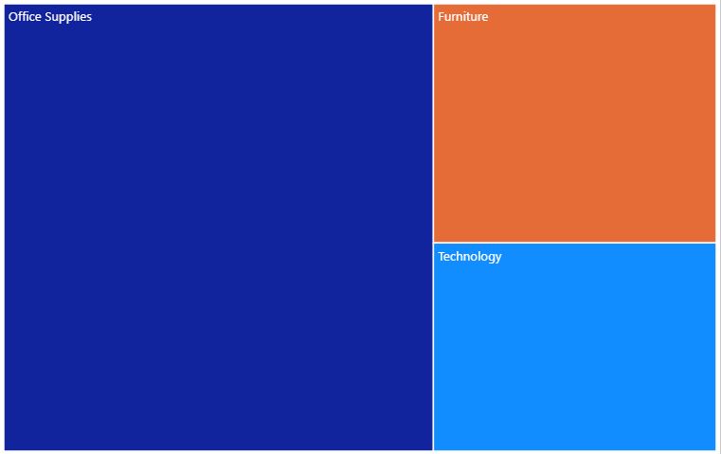

Count of Quantity by Category

OFFICE SUPPLIES HAVE MAXIMUM COUNT OF QUANTITY

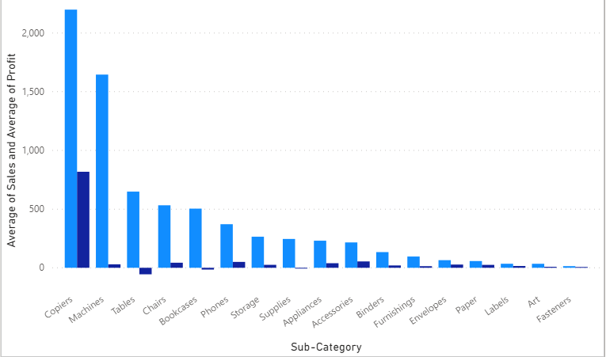

Average of Sales and Average of Profit by Sub-Category

COPIERS GET MAXIMUM PROFIT AS WELL AS MAXIMUM SALE WHEREAS TABLE , BOOKCASES AND SUPPLIES GET LOSS EVENTHOUGH SALE IS GOOD

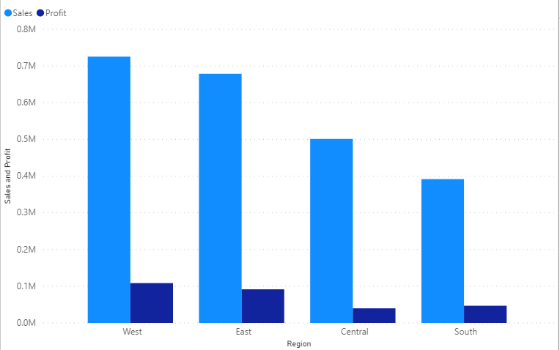

Sales and Profit by Region

WEST AND EAST ZONE ARE NEARLY EQUAL IN PROFIT

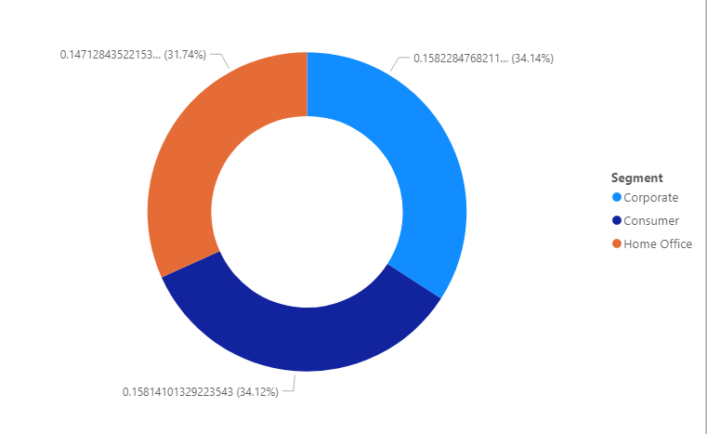

Average of Discount by Segment

ALL SEGMENTS NEARLY GIVE EQUAL DISCOUNT(in avg)

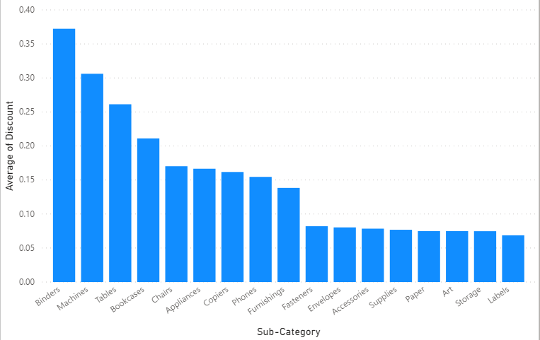

Average of Discount by Sub-Category

MAXIMUM DISCOUNT IS GIVEN FOR BINDERS , 3RD MAXIMUM DISCOUNT IS GIVEN FOR TABLES, SO THEY GET LOSS IN SELLING TABLE.